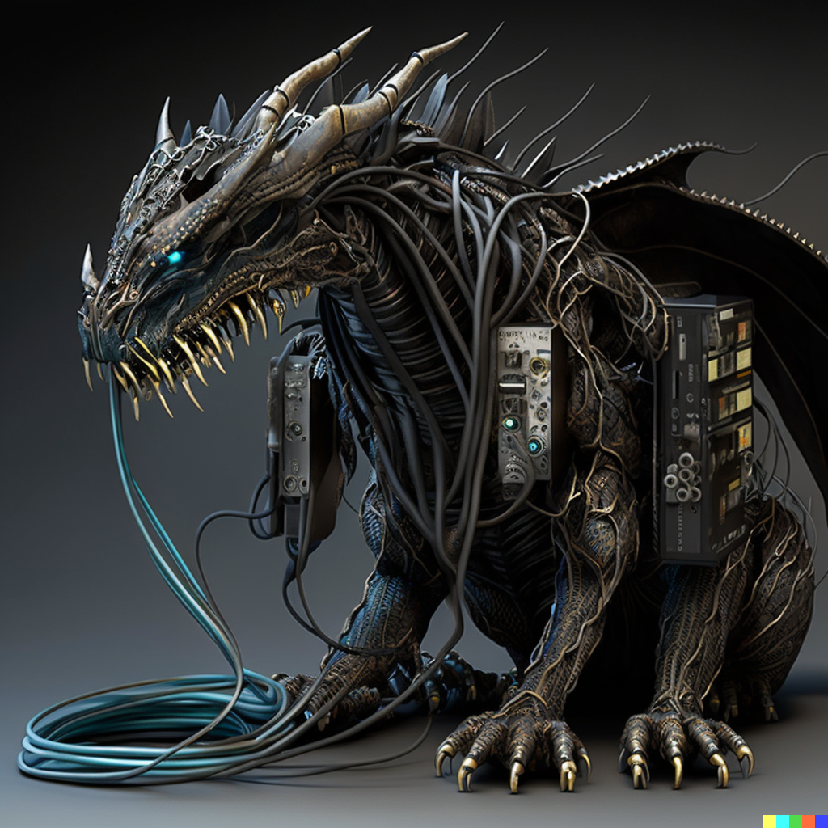

**We don't see things as they are, we see them as we are**

**Genres**  
  
  
  
Action RPG